Physics Syllabus: 2016-2017
Welcome to Physics! Physics means “knowledge of nature” and studies forces, energy, and motion through space and time. It is the foundation of other sciences as we observe how the universe fundamentally behaves. This course focuses on Mechanics, where we will analyze physical laws that describe the motion of macroscopic bodies. Other topics of physics include electricity and magnetism, thermodynamics, waves, sound, light, relativity, and quantum mechanics.
What separates physics from other sciences is how the material is studied. Physics entails solving problems and will therefore require a new way of thinking. You will develop your ability to analytically and logically reason through nuanced ideas.

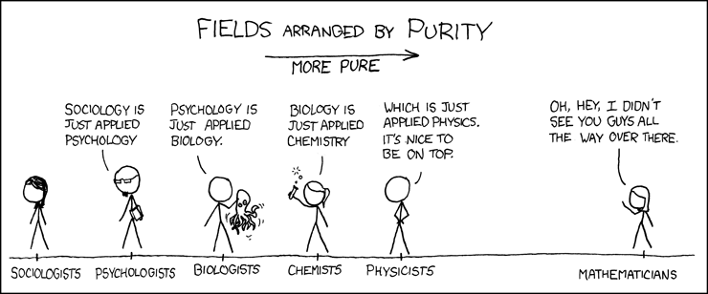
Topics we will cover include:
Unit 0: Introduction to the Scientific Method
Unit 1: Constant Velocity and Acceleration
Unit 2: Forces
Unit 3: Projectile Motion
Unit 4: Centripetal Force
Unit 5: Energy Conservation
Unit 6: Modern Physics and Relativity

Many different math topics are used to understand the physics concepts and to solve problems. Here is a list of relevant math topics that will be used throughout the year so you can review and pay extra attention in math class.
- Unit conversions
- Graphing linear, parabolic, and inverse functions
- Algebraic manipulation
- Derivatives and integrals (Calculus)
- Vector addition
- Trigonometry (sin θ, cos θ, tan θ)
- Scientific notation

Throughout the year, I hope you are determined to give your best to learn the material. In case you would like extra practice or resources, I recommend the following:
- Khanacademy.org
- Institute of Physics (YouTube)
- Crash Course (YouTube)
- Physicsclassroom.com
- MinutePhysics (YouTube)
- The Cartoon Guide to Physics (see physics library)
- Physics textbooks (see physics library)

If you need additional help, come to my Afterschool on Wednesday and Breakfast study on Thursdays in Barbara’s room (312).

Standard Based Grading:
This class uses Standard Based Grading to assess set standards. Standards are assessed during quizzes with four categories of grades:
- = Low Mastery (LM) – little to no understanding of main idea
- = Approaching Mastery (AM) – basic understanding of main idea, with major gaps
- = Mastery (M) – strong understanding of main idea, with minor conceptual errors
- = High Mastery (HM) – thorough understanding of main idea and
If you would like to improve your grade on a standard, you may retake a quiz as many times as needed, and your best grade will be inputted. Before retaking a quiz, complete a quiz correction.

Grade breakdown:
Participation
5 | Actively and respectfully contributes to class discussion
4 | Takes notes, respectfully listens, follows directions
3 | Disengaged, sleeps in class, chats with neighbors
2 | Disruptive, actively distracts neighbors
1 | Hostile, resists teacher intervention
- HW/classwork: 15%
- Labs: 20%
- Quizzes/tests: 30%
- Exhibitions: 30%
- Participation: 5%

Class policies:
- Quizzes can be made up any number of times. You must do a quiz correction before retaking a quiz.
- Late homework assignments will be deducted points.
- Late lab reports and exhibitions will be docked for each day it is late.
- Students who are absent for X days will have X+1 days to make up missing work. Afterwards, it will be considered late.
- Unless directed by the teacher, phones should never be out in the classroom. If your phone is out, your teacher will hold on to it. You may pick it up during lunch or afterschool. Refusal will prompt the teacher to notify the dean for an automatic Friday RT. If you need to take an urgent call or message, let your teacher know and she will excuse you.
- If you need to use the restroom, your teacher will hold on to your phone.

Class expectations:
Students are expected to always follow two essential rules in the classroom.
- Respect
  - The space. Throw away your trash, push in your chair, and be careful with materials
  - Others. Give others the best opportunity to learn by listening intently, respecting their space and belongings, and putting your phone away.
  - Yourself. You should have high expectations for yourself and always strive for better.
- Safety
  - Physical. Please do not throw objects (unless instructed in a lab!)
  - Social and emotional. This is a judgement-free zone where we need to rely on each other to learn. This is a safe place to make mistakes. Use supportive language.

Email: yenminy@eschs.org
Advisory: Rm 308 (science prep room)
Physics: Rm 312 (Barbara’s room) [except on Fridays: Rm 317 (Desiree’s room)]

