**Introduction to**

**6th Grade Science**

CLASS WEBSITE:

eschs.libguides.com/6thgradescience





Name: ________________________

**Inside:**

* Letter to Students and Families
* Course Outline
* Grading Policy
* Class Rules and Procedures
* Supply List

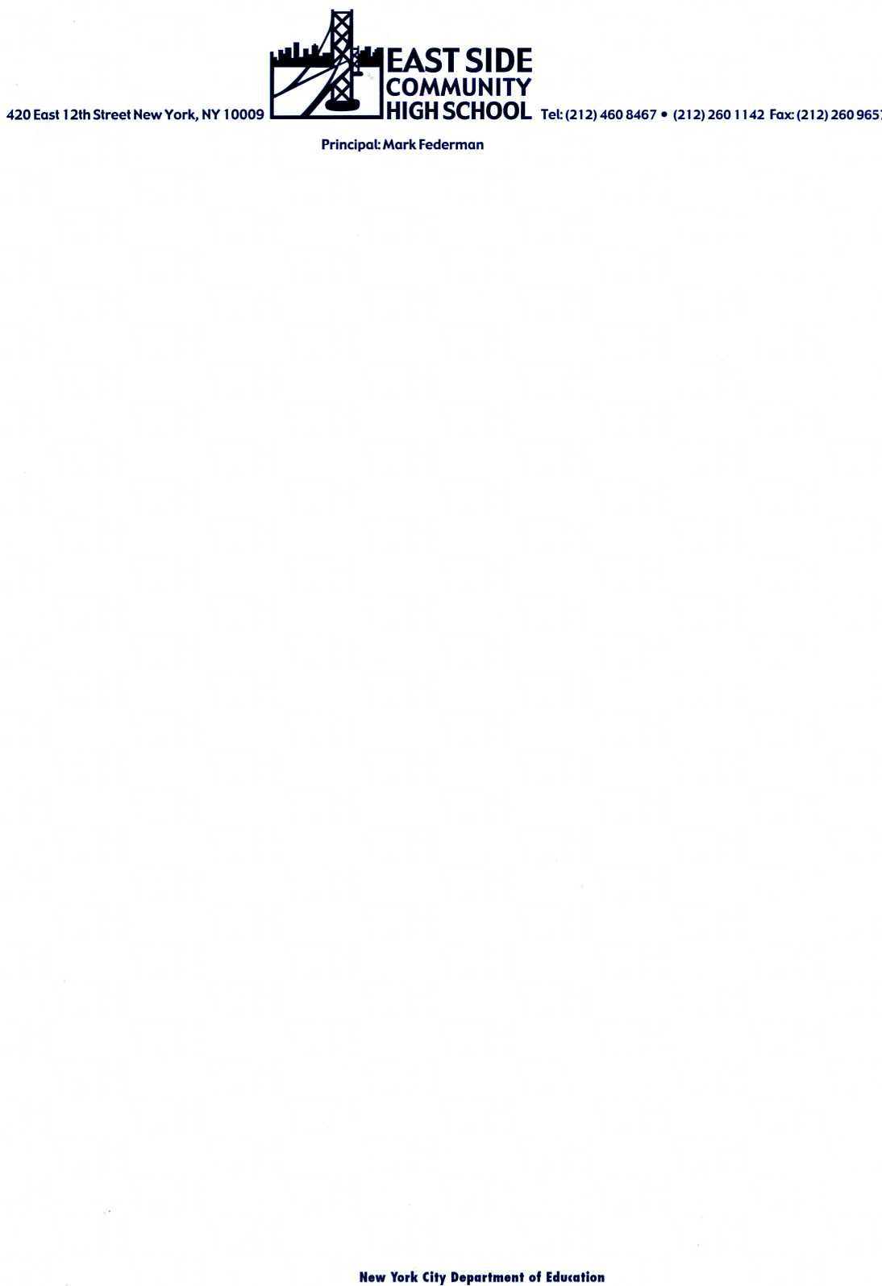

Dear Students and Families,

Welcome to **Sixth Grade Science** at East Side Community High School! This is sure to be a year of questioning, observing, investigating, experimenting, collaborating, and, of course, critical thinking.

The sixth-grade science curriculum is designed to provide students with a strong science foundation, one that will serve them throughout their science education at East Side and beyond. To this end, we will focus this year on skills that are highly transferable across science disciplines – asking questions, designing controlled experiments, collecting, representing, and critically analyzing data, articulating conclusions using evidence, and conducting research. Great emphasis will be placed on science literacy – lessons will regularly incorporate a variety of current science texts and articles, and students will write about science on a daily basis. Many activities will be hands-on, student-centered, and technology-based. Overall, students will be taught to approach the world as scientists do, using the tools, methods, and critical eye of real-world scientists.

In the following pages you will find information about the science units we’ll be studying this semester, the class grading policy, and class rules, procedures, and expectations. If you have questions at any point regarding class assignments or student progress, please feel free to e-mail me, and/or consult the class website:

[eschs.libguides.com/6thgradescience](http://www.eschs.libguides.com/6thgradescience)

Lastly, please note that Polly will be available in her classroom (Room 201) for after-school Homework Help every Monday from 3:30 – 4:30pm, and for Breakfast Study every Tuesday from 8:00 – 8:40am.

Looking forward to a great year,

Polly Seplowitz

pollys@eschs.org

Debbie Mohamed (Learning Specialist)

debbiem@eschs.org



**6th Grade Science Course Outline**

CLASS WEBSITE:

[eschs.libguides.com/6thgradescience](http://www.eschs.libguides.com/6thgradescience)

**I. Instruction Time:** This is a semester-long course that meets five days a week: two 54-minute periods, two 47-minute periods, and one 45-minute period.

**II. Curriculum:**

**UNITS #1 – 3: Experimental Design, Bias, and the Ethics of Experimentation (Fall Semester)**

* **Essential Question:** How do scientists design and conduct experiments to answer questions about their world?
* **Objectives:** Students will learn how to…
* Develop scientific questions that are testable through experimentation.
* Design controlled, randomized experiments in order to find answers to scientific questions.
* Maximize the validity of their experiments.
* Apply strategies that serve to minimize the effects of experimenter bias and test subject bias on experimental results.
* Weigh the ethical issues at stake when formulating an experimental design.
* Closely read scientific texts.
* **Major Assessments:** Students will complete an Experimental Design Proposal, which will outline an experiment of their own design, related to an assigned topic. The assignment will require background research, a rationale, experimental design components, a procedure, and any relevant ethical considerations. Students will present their proposal to their classmates, and make adjustments based on peer feedback. Students will also complete smaller research assignments, including one assignment that will culminate in a debate. Quizzes will be given every 2-4 weeks.

**UNIT #4: Representing and Analyzing Data (Spring Semester)**

* **Essential Question:** How do scientists use experimental data to draw valid conclusions?
* **Objectives:** Students will learn how to…
* Organize data into charts and tables.
* Represent data using appropriate graphing methods.
* Identify trends in data, and relationships between experimental variables
* Use both raw data and mean data to formulate a claim/conclusion that addresses an experimental question.
* Use research and science knowledge to explain experimental results.
* Identify experimental sources of error.
* **Major Assessments:** Students will be given a series of graphs and data sets, will be required to critically analyze the data presented, and to utilize this data to compose nuanced written conclusions.

**UNIT #5: Performance-Based Assessment Task (PBAT)**

In this final, culminating unit, students will apply the enduring understandings they have built throughout the year to conduct an independent investigation of their own design. This investigation will require knowledge of both experimental design and data analysis. They will conduct research to identify a testable question, design an experiment, collect data, analyze data, and draw data-based conclusions. They will then present their research to both adults and peers at June Rountables.

**III. Grading Policy**

You will receive TWO grades for this class – an achievement grade and a work habits grade:

|  |  |  |
| --- | --- | --- |
| **Achievement Grade:**  Based on Content Mastery | | |
| **35%** | **Tests and Quizzes** | Quizzes (given every 2-3 weeks) and unit tests |
| **30%** | **Exhibitions** | Lab reports, extended writing assignments, projects, Roundtables |
| **10%** | ***Write Now* Assignments and Exit Slips** | Daily writing assignments that assess current understanding of science content |
| **25%** | **Science Literacy** | CER writing; NewsELA assignments + quizzes; Research |

|  |  |  |
| --- | --- | --- |
| **Work Habits Grade:**  Based on Timely Completion of Assignments and Class Participation | | |
| **55%** | **Homework/Exhibition Completion** | Reflects whether assignments were submitted complete and on time (see class website for *Homework* rubric) |
| **25%** | ***Write Now* Completion** | Reflects whether *Write Now* assignments were completed in a timely fashion, and organization of science notebook (see class website for *Science Notebook* rubric and description) |
| **20%** | **Class Participation** | Preparedness, adherence to class rules and procedures, raising hand to participate in class lessons, on-task behavior (see class website for *Class Participation* rubric and description) |

**A. Homework/Classwork/Exhibition Policies:**

* Homework will be assigned almost everyday, and will be checked or collected at the beginning of class the next day.
* All homework assignments will be graded out of a score of 10. Grades will be assigned based on **EFFORT** and **COMPLETION**, and will count toward students’ **WORK HABITS** grade. See the Homework Rubric below!
* All homework assignments will be posted on both the 6th Grade Website 4pm each day.
* NO late homework or classwork assignments will be accepted, except on a case by case basis. Students unable to complete a homework assignment on time are expected to provide advance notice via email or a note of explanation from a doctor or parent. Conditions for making up missed assignments should be discussed with Polly. Late work will incur a 15% grade deduction per day.
* Missing homework assignments will receive a score of 0.If a student is absent, he/she is responsible for requesting all missing work on the first day back in school, and HW will be due the following day. Students may also check the class website to retrieve the HW assignment.
* Exhibitions and other Achievement assignments WILL be accepted late, but will incur a 10% grade deduction for each day the assignment is late (the deduction will apply to the Work Habits component of the grade).
* All missing exhibitions and Achievement assignments will receive a score of 45%.

**Homework Rubric**

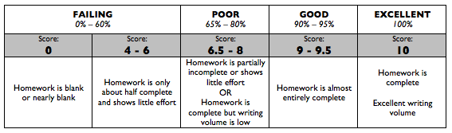

**B. Test/Quiz Policies:**

* Students will be given at least two days’ notice before quizzes, and one week’s notice before tests.
* Students who are absent on test/quiz days are expected to make up the exam at science Homework Help on the first Monday after it was given.
* Missing test/quiz grades will receive a score of 45%.

**IV. Year-Round Rituals**

* *Write Now and Read Now* Assignments: *Write Nows* and *Read Nows* occur at the beginning of class each day. The *Write Now* is a daily writing exercise completed by students in their science notebooks at the beginning of most lessons. The *Read Now* requires that students read through their notes from the previous day, and then answer 1 or 2 review questions based on these notes. These beginning-of-class assignments are intended to review the prior day’s lesson, or to preview the lesson to come.
* Science Literacy (SciLi) Fridays: Students will read, analyze, and complete written assignments using current science articles and texts. Some Fridays will focus on science writing.
* CER Assignments: The CER– an acronym for claim, evidence, reasoning – is a type of writing assigned 1-2 times per week in ELA, History and Science classes. While CERs vary in length and formality, they always require that students take a position, and support this position with text-based evidence and reasoning. CERs also require that students incorporate content-specific knowledge and vocabulary, and follow grammar conventions. A rubric is available on the class website.

**V. Required Supplies**

Each day, students must come to class with:

* A composition notebook: This will be used for daily class notes and Write Now assignments.
* A green plastic 2-pocket 3-prong folder (purchase from Polly for $2): This will be used for all science handouts.
* Two sharpened pencils everyday

In addition, contributions of the following would be greatly appreciated:

* A roll of paper towels
* A box of tissues

**VI. Class Website**

**eschs.libguides.com/6thgradescience**

The 6th Grade Science website will be updated on a daily basis. Check the website regularly for:

* each day’s homework assignment
* important class announcements
* assignment rubrics
* science links

**VII. Classroom Rules & Consequences**

1. Show 100% RESPECT for yourselves, your classmates, your teacher, and your classroom.
2. Listen to and follow directions the first time they are given.
3. No cursing or put-downs.
4. No food, drinks, hats, or electronics in the classroom.
5. Clean up after yourselves!

Failure to follow classroom rules will result in a range of **consequences**:

verbal warning 🡪 write-up to advisor + call home 🡪 write-up to the dean + DT 🡪 Friday suspension

**VIII. Classroom Procedures**

**BEGINNING CLASS:**

**1) Entering the Classroom:** You will enter the classroom quickly and quietly, following the procedures below:

1. Line up silently outside the classroom, with FOUR items already in your hands:

#1: Orange HW log #2: Green science folder #3: science notebook #4: a sharpened pencil.

1. Pick up any handouts distributed by the door.
2. Silently head straight to your assigned seat.
3. Place last night’s homework assignment at the corner of your desk, to be checked and stamped.
4. Copy tonight’s homework into your HW log.
5. Copy the day’s date into your notebook and READ today’s Objective.
6. Begin the day’s *Write Now* (in your notebook) or *Read Now* (5-10 minutes).

**DURING CLASS:**

**2) Always S.L.A.N.T.:** When anyone in the class is speaking – whether a student, your teacher, or a guest speaker – you should always be SLANTing:

**S**it up straight **L**isten **A**sk and answer questions **N**od **T**rack the speaker

**3) Bathroom:** You may not use the bathroom in the first or last 10 minutes of class, or during whole-class instruction. You may raise your hand to ask permission to use the bathroom during independent work. When given permission to leave the room, you must take the pass. Only one person may leave the room at a time.

**4) Raise Your Hand!:** Do not speak when others are speaking, and do not call out. Raise your hand to ask a question, answer a question, or to get permission to leave your seat. Wait silently to be called on.

**5) Sharpening Your Pencil:** You may NOT sharpen your pencil during whole-class instruction/discussion. It’s disruptive! Pencils may be sharpened during the *Write Now* and during independent work.

**6) Borrowing Writing Utensils:** If you come unprepared to class and need to borrow a writing utensil, you will have to borrow one from Polly. If you have borrowed a writing utensil more than once in 1 month, your participation grade will be affected.

**7) Independent Work:** During partner or group work, keep your voices DOWN. During individual work, remain SILENT. Raise your hand if you need help.

**ENDING CLASS: Dismissal:**

**8)** Do not get up until one of your teachers officially dismisses you.

**9) Clean Up:** Before you leave, make sure that all borrowed materials have been returned to their appropriate location, that your desk is empty, that your desktop is clear, and that the floor around your desk contains no trash.

**10) PUSH IN YOUR CHAIR!**

**I, ______________________________, have read and understand all of the expectations, rules, and procedures described in the 6th grade Science Course Outline.**

Student Signature: ________________________________

Guardian Signature: _______________________________

_____________________________________             _____________________________________