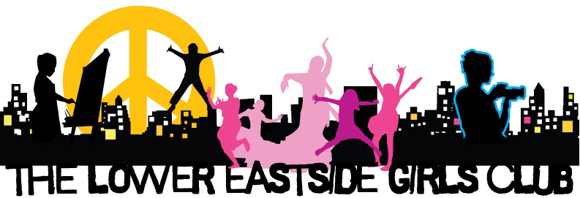

Raising the Next Generation of Ethical, Environmental and Entrepreneurial Leaders!
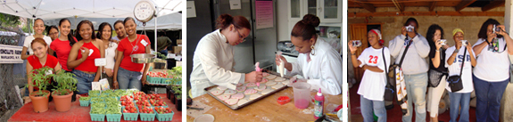
BioBase at the LES Girls Club is running a special
Science Sisters program just for our students on
Fridays from 1:30 to 3:30!! If interested see Tom!

ABOUT OUR PROGRAMS: Girls Club programs fall into three overlapping categories that work to build Ethical, Entrepreneurial and Environmental awareness and leadership. Through an ever changing and age appropriate menu of activities and workshops in the arts, science and technology, health and wellness, literacy, world of work and civic engagement, we help girls discover what their individual skills and passions are, and then work with them to develop these interests to their full potential.

The Girls Club also runs several social venture businesses: The Art+Community Gallery, La Tiendita Fair Trade and Girl Made Gift Shop at the Essex Market, and theSweet Things Bake Shop. All of our programs develop environmental, entrepreneurial and ethical leadership in the girls we serve. The Girls Club is committed to a project-based experiential learning model of education. For grammar school girls (grades 4-6) this means programs in schools that complement, rather than duplicate, the work of the educational community—providing activities focused on science, wellness and nutrition, and mentoring. Ex: Fairy Tale Yoga, Arts, Photography, Choir, Homework Help, Museum Club, Book Club and Summer Camp.

For middle school girls (grades 7-9) we run programs that require individualized and small group settings that help focus the girls during these particularly ‘distracting’ years.Ex: Digital Filmmaking, Photography, Nutrition Workshops, Homework Help, Book Club, Crafty Chicas, Science Sisters and Summer Leadership Institute.

Middle school girls are also involved with our high school girls (grades 10-12) in a wide variety of workshop offerings and ongoing programs held at the Girls Club’s literacy center, digital film, photography and technology lab, our community radio station, art gallery, and bakery. Ex: Leadership Development and Civic Engagement, Job Skills and Entrepreneurial Training, Financial Planning, Science and Technology Programs, Summer Jobs and Camp. Older high school and college students are also involved in Career Development and Academic Support Activities. Free Public Programming for families and the entire community is available every Saturday afternoon during the school year.

Moving into the new Lower Eastside Girls Club Center for Community in 2013 will allow us to expand our programs, providing more inter-generational services, job training, academic, health, and community support. The Tyra Banks TZONE at the Lower Eastside new Girls Club will be a leadership development center within the Girls Club. Through a rich mix of career development workshops, mentoring, experiential learning opportunities, financial literacy initiatives and community-wide events, hundreds of preteens and teens will build self-esteem, achieve greatness in their lives, and prepare for life as entrepreneurs and change-makers in the world.

ENTREPRENEURIAL TRAINING & SOCIAL VENTURE PROGRAMS
Sweet Things Bake Shop located at 136 Avenue C between 8th and 9th Streets, is a training and production site for our entrepreneurial programs.

© The Lower Eastside Girls Club | 101 Avenue D, NYC, NY 10009 | (212) 982-1633

